Content Marketing Plan

Profile Plan

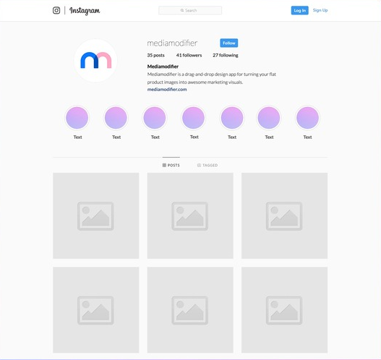

Bio Mock up:
DR RAMANPREET SIBIA
@DrRamanpreetSibia
Credentials (e.g. Doctor)
Specialities
Call to Action (e.g. to people loving the skin they’re in)
Location + Credential/title (e.g. Melbourne Doctor/derma)
Offer app option (e.g. DM to Book or ph:…. Or book via *website*)
Address
Website URL

PP mock up:
Profile Picture - headshot from website

HL Mock up:
Highlights – suggested list
- One for each treatment
- One for news update
- One for “about me”

Grid Mock ups:
Posts curated from plan and colour pallets, all made on CANVA.

Content Info:
Content Pillar From Marketing Coordinator Xyrenne Eustquio adapted

Content Pillar | Purpose
Educational | Build trust through expert knowledge
Product Promotion | Increase product/service sales
Client Results | Showcase credibility and outcomes *needs to be edited – no before and afters – maybe with Rejuran?
Behind-the-Scenes | Humanise the clinic and staff *showcase room/area and staff
Skincare Tips | Provide value & increase retention
Trends & Awareness | Stay culturally relevant *stick to trendy sounds – other trends can come off unpro
Client Engagement | Boost interaction & community
Interactive/Engagement | Foster audience feedback and input

Mia’s notes:
- LEDs
- DermaPen
- Dysport – anti-wrinkle/filler
- Rejuran
- Skincare
- Websites for content: Dermapen, Healite and Rejuran

Keep ideas flowing:
Start off with 3 posts a week and see how it goes:

First couple of posts before content plan with content pillars incorporated are essential to introduce yourself & the clinic.
First post: Introduction – like quick blurb/credential check. It personalises things and forms trust.

Now content pillar plan:
Marketing plan edited
Mix education, personality and photos.

Week | Post # | Content Pillar | Topic
Week 1 | Post 1 | Educational | LED Light Therapy Explained (Slides)
Week 1 | Post 2 | Product Promotion | Highlight Skincare Range (photo placement)
Week 1 | Post 3 | Behind-the-Scenes | DermaPen Treatment Explanation (slides)
Week 2 | Post 1 (story) | Client Engagement | Quiz: “Which Treatment is Ideal?” (Personalise – if you are *blank* and *blank* do this…
Week 2 | Post 2 | Client Results | Maybe Rejuran? Reevaluate*
Week 2 | Post 3 | Skincare Tips | How to Layer Skincare (personalise – give examples)
Week 3 | Post 1 | Trends & Awareness | Morning routine – derm approved (personalised)
Week 3 | Post 2 (story) | Interactive/Engagement | Poll: Filler or Facials? (encourage interactive comment section)
Week 3 | Post 3 | Educational | Benefits of Skin Needling (slides)
Week 4 | Post 1 | Trends & Awareness | Reel idea: POV: You finally find the right sunscreen (simultaneously product placement and funny trend)
Week 4 | Post 2 | Product Promotion | Featured Product of the Week (photo placement)
Week 4 | Post 3 | Behind-the-Scenes | A Day at the Clinic (tour of clinic + show how to get to the clinic in the centre – can be hard – makes it easier)
Week 5 | Post 1 | Trends & Awareness | Skin Positivity Campaign (skin cancer awareness)
Week 5 | Post 2 | Educational | How Fillers Work (Explainer)
Week 5 | Post 3 (story) | Client Engagement | FAQ Friday – Ask Dr. Raman (use anon questions)
Week 6 | Post 1 | Skincare Tips | How to Prep Skin Before Treatment (slides or reel)

Colour Pallet Options:
Pallets for photos and slides on grid.

Option one
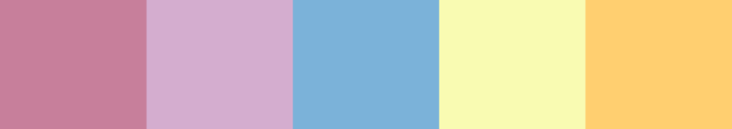

Option two
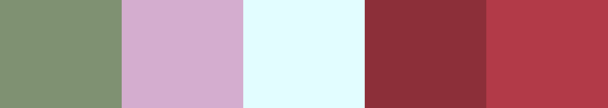

Option three
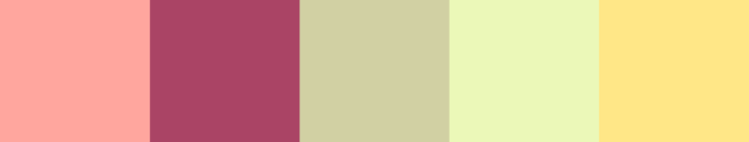

Option four (varirant of three)
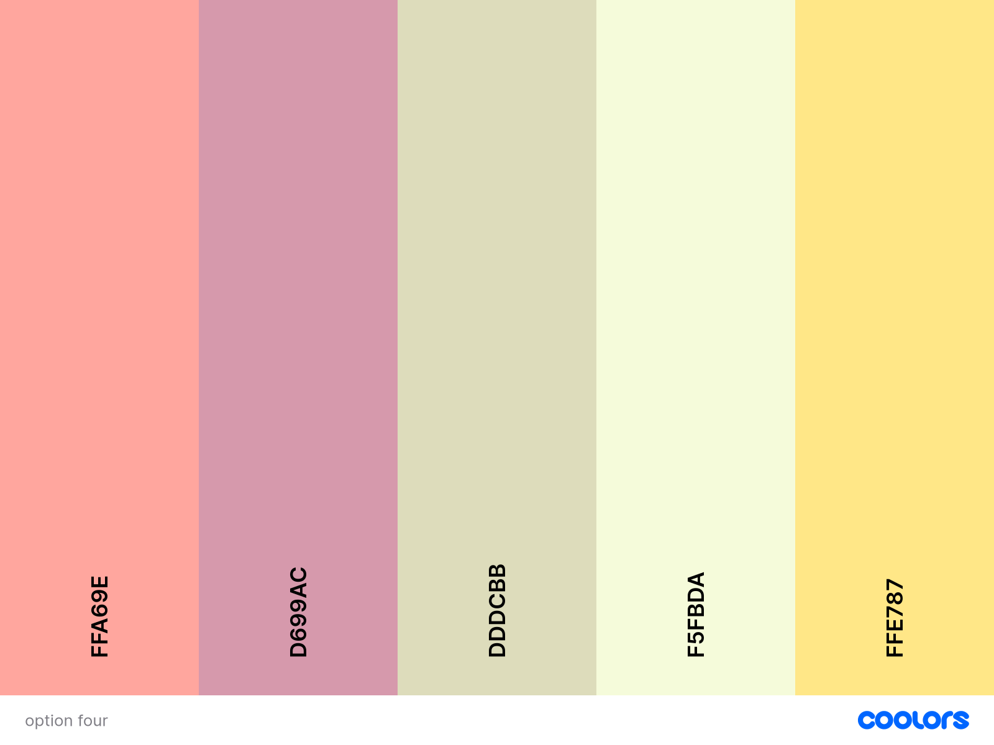

Example of pallet appearance
